Varvara Shavrova
PORTFOLIO

www.varvarashavrova.com

Varvara Shavrova is a visual artist born in the USSR who lives and works between in Dublin. Shavrova’s practice is focused on excavating the layers of her family’s history in the Soviet Union through the process of remembering, recalling, retracing and re-enacting stories. In engaging memory, nostalgia and reflection, Shavrova creates installations that make connections between historic and current narratives, between the archival and the present.
In her work, Shavrova examines the symbols of power and authority whilst investigating their relationship to the individual. The process of empathy is the means of materializing the past into the present. The materiality of Shavrova’s installations is a comment on women’s labour, and engage with methodologies of drawing, digital printing, tufting and weaving.

Shavrova studied at the Moscow State University of Printing Arts, and received her Masters in Fine Arts from Goldsmiths, University of London. Shavrova’s recent project Inna’s Dream reinterprets the first Soviet amphibious aeroplane designed by her great uncle in 1930s, and includes tufted carpet objects and site-specific drawings installation at Patrick Heide Contemporary Art, London (2019). Mapping Fates, multi-media installation reflects on Shavrova’s family migration, and includes tapestries and sound, shown in Lenin’s apartment in St. Petersburg (2017). Shavrova’s project The Opera portrays the gender fluidity in traditional Peking opera. The Opera received international acclaim and includes photography, sound and video projections, and was shown at The Temple Beijing (2016), Momentum Berlin (2016), the Gallery of Photography Ireland (2014), the Venice Biennale of Architecture (2014) and at Espacio Cultural El Tanque in Santa Cruz de Tenerife (2011). Shavrova’s multi-media project Borders (2007-2015) examines the geo-political tensions between Russia and China and was shown in her solo exhibitions at the Moscow Museum of Modern Art (MMOMA), at the Museum of the History of St. Petersburg in Rumiantsevski Palace, and at the Galway Arts Festival in Ireland. Shavrova received awards from the Arts Council England, Arts Council Ireland, Culture Ireland, British Council, Ballinglen Arts Foundation, and The Prince’s Trust. She has been awarded the artist’s grant for her socially-engaged, textile-based projects in the Irish prisons, supported by the Arts Council of Ireland ‘Artists in Prisons’ Scheme. Shavrova also curated international visual arts projects, including The Sea is Limit exhibition at York Art Gallery (2018) and at Virginia Commonwealth University Arts Qatar Gallery in Doha (2019), examining migration, borders and refugee crisis, and presented The Sea is the Limit project at Tate Modern ‘Who Are We?’ public event as part of Refugee Week 2018, in collaboration with Counterpoint Arts and Tate Exchange. She curated Giving Voice, the exhibition of Mary Robinson’s presidential archive in Ballina library in County Mayo, Ireland and Map Games: Dynamics of Change, international art and architecture project, at Today Art Museum in Beijing, at Birmingham Museums and Art Gallery, and CAOS Centre for Contemporary Arts, Terni, Italy (2008-2010). Shavrova’s works are included in the collections of the Office of Public Works and the Department of Foreign Affairs and Trade in Ireland, the Momentum Collection Berlin, the Ballinglen Museum of Contemporary Art Ireland, Minsheng Art Museum Beijing, Moscow Museum of Modern Art, and the Museum of the History of St. Petersburg. Shavrova’s work is represented by Patrick Heide Contemporary Art, London.

www.varvarashavrova.com

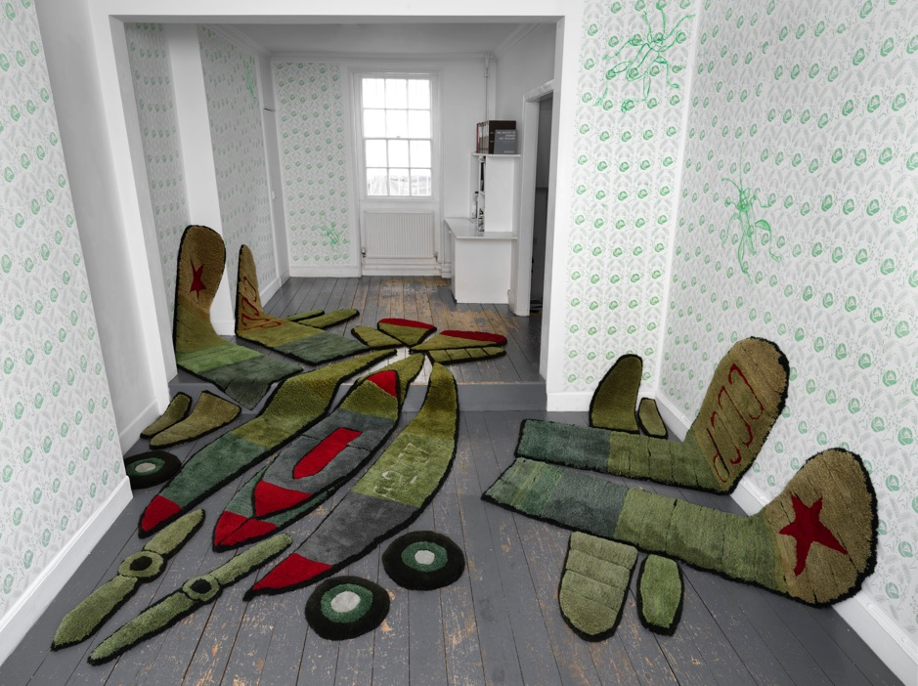

Inna’s Dream
2019
Hand tufted Axminster wool, hessian canvas backing, thread, relief print and acrylic drawings
7 metres by 5.5 metres by 3 metres. Installation at Patrick Heide Contemporary Art London
The first Soviet amphibious aeroplane that was designed by my great uncle in the Soviet Union in 1930s is scaled down and re-made as a three-dimensional textile object. The installation is
a demilitarised and domesticized representation of a deflated military machine, the collapsed dream of the powerful and the ‘high flying’, the infantile giant toy kit symbolic of capitulated
militarism that challenges the core symbolism of masculinity and power.
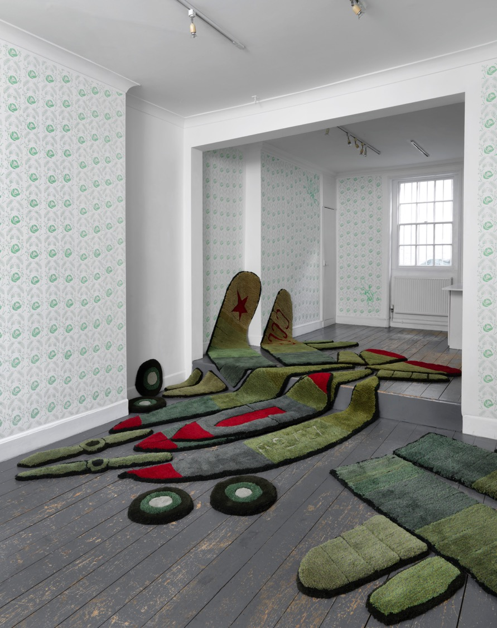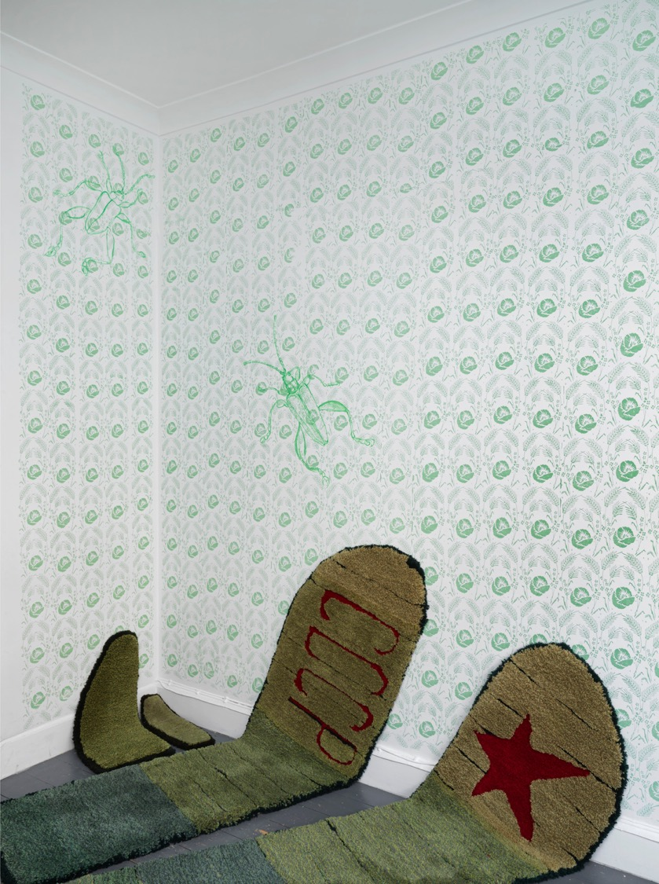
Inna’s Dream
2019
Hand tufted Axminster wool, hessian canvas backing, thread, relief print and acrylic drawings.
7 metres by 5.5 metres by 3 metres.
Installation at Patrick Heide Contemporary Art London
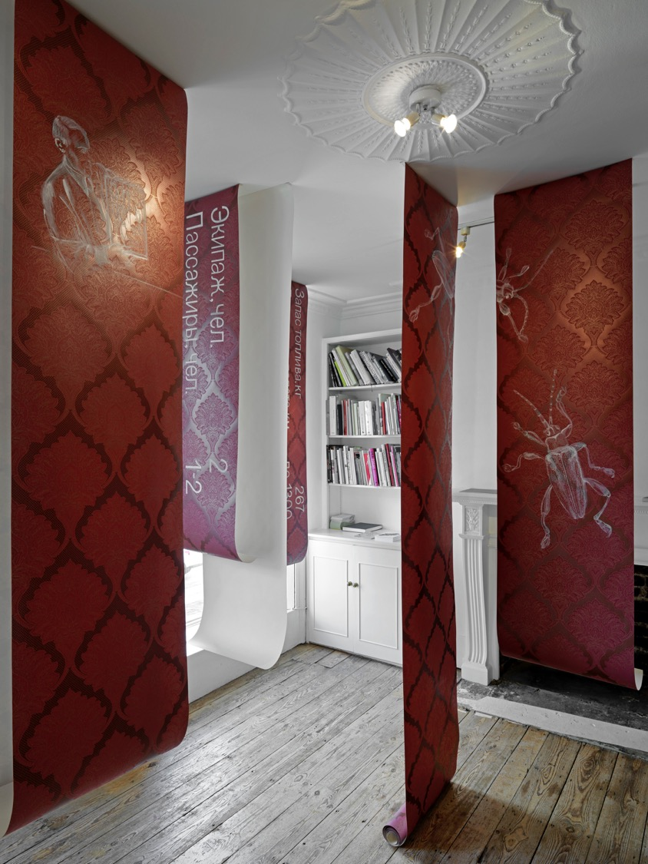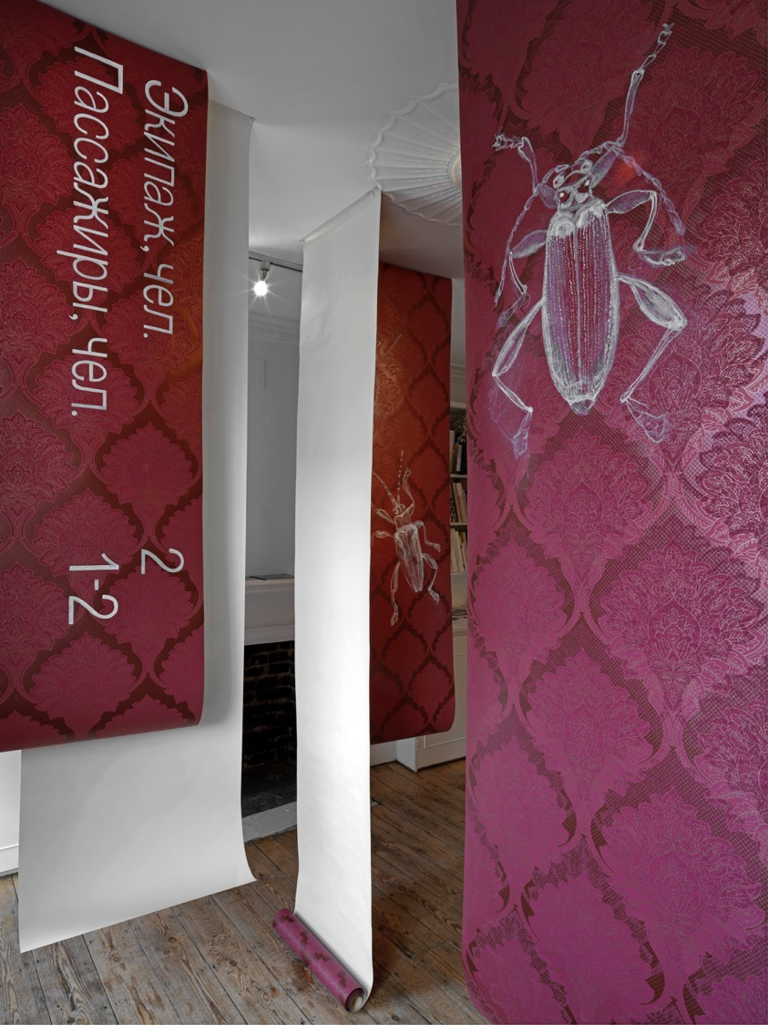

Inna’s Dream
2019
11 drawings, acrylic on wallpaper, metal pins.
7 metres by 7 metres by 3 metres.
Installation at Patrick Heide Contemporary Art
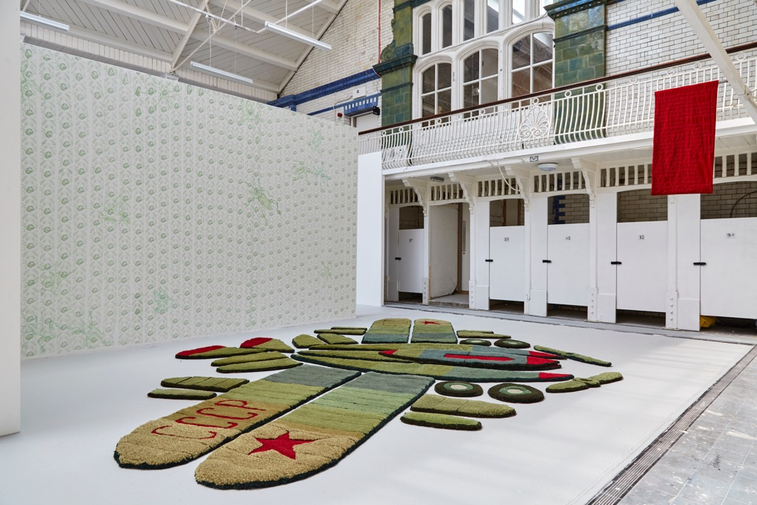

Inna’s Dream
2019
Hand tufted Axminster wool, hessian canvas backing, thread, digital embroidery on velvet, steel support, acrylic and emulsion on wall.
7 metres by 5.5 metres x 4 metres. Installation at Goldsmiths MFA Degree show, Laurie Grove Baths, London
Photo: Corey Sanderson
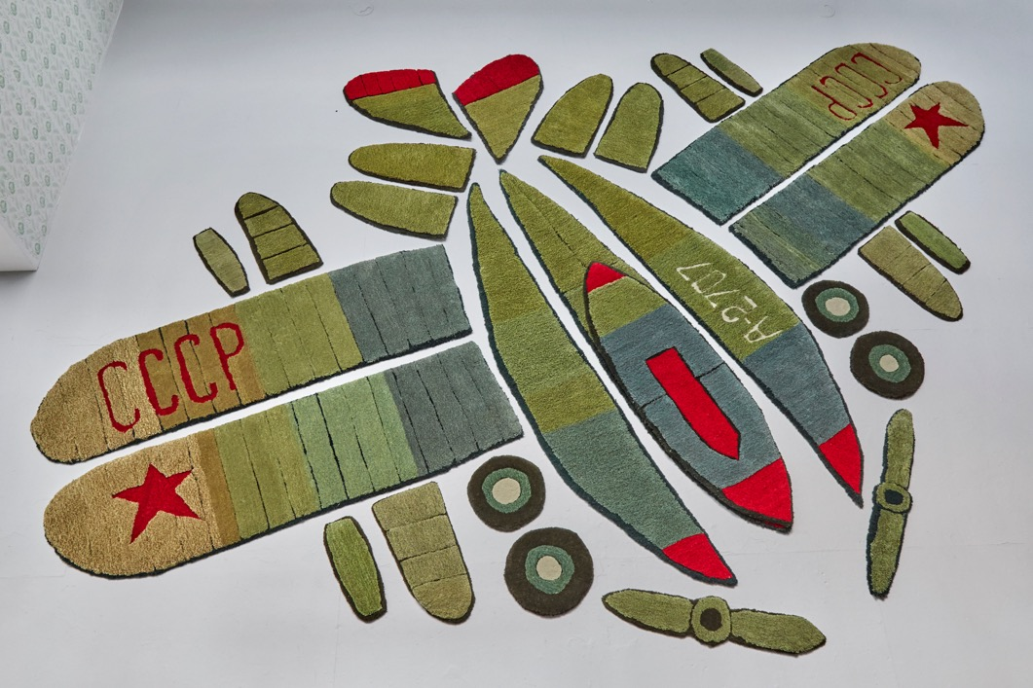

Inna’s Dream
2019
Hand tufted Axminster wool, hessian canvas backing, thread, digital embroidery on velvet, steel support, acrylic and emulsion on wall.
7 metres by 5.5 metres x 4 metres. Installation at Goldsmiths MFA Degree show, Laurie Grove Baths, London
Photo: Corey Sanderson
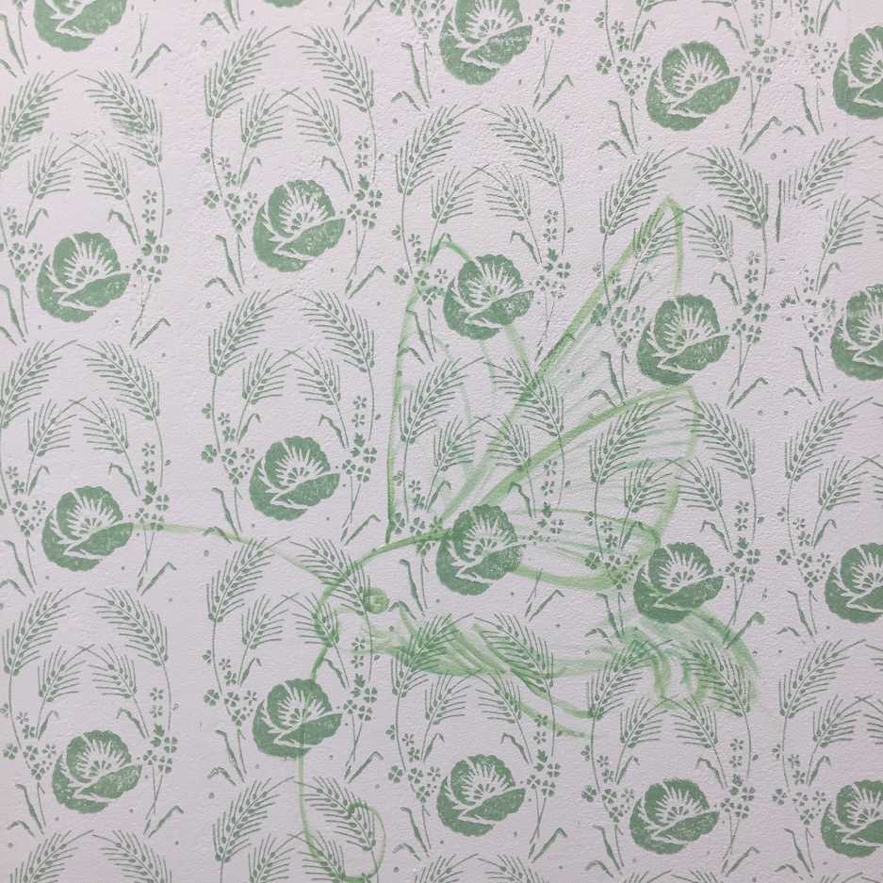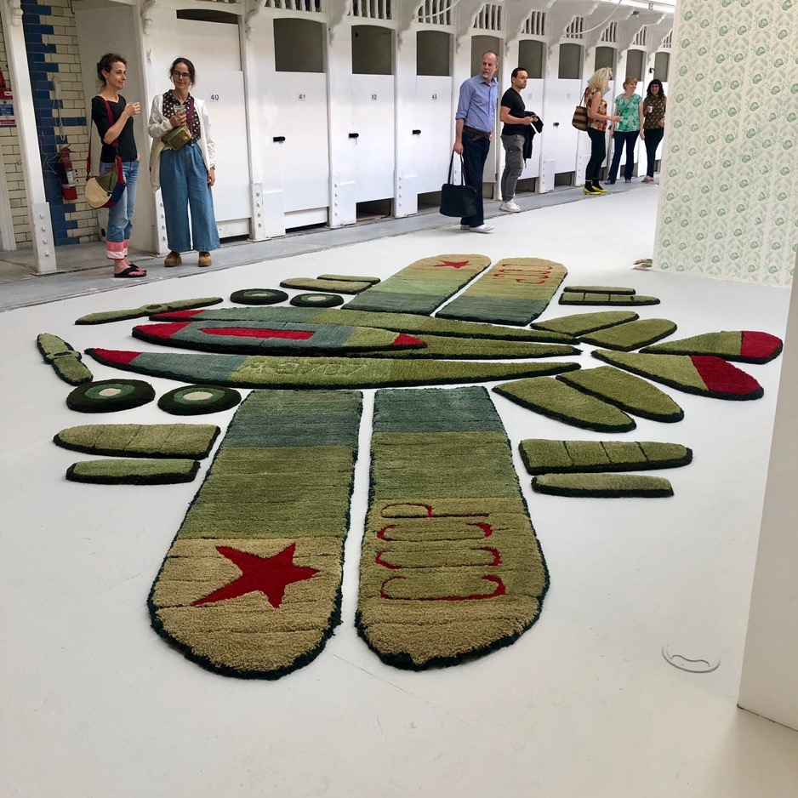

Inna’s Dream (detail)
2019
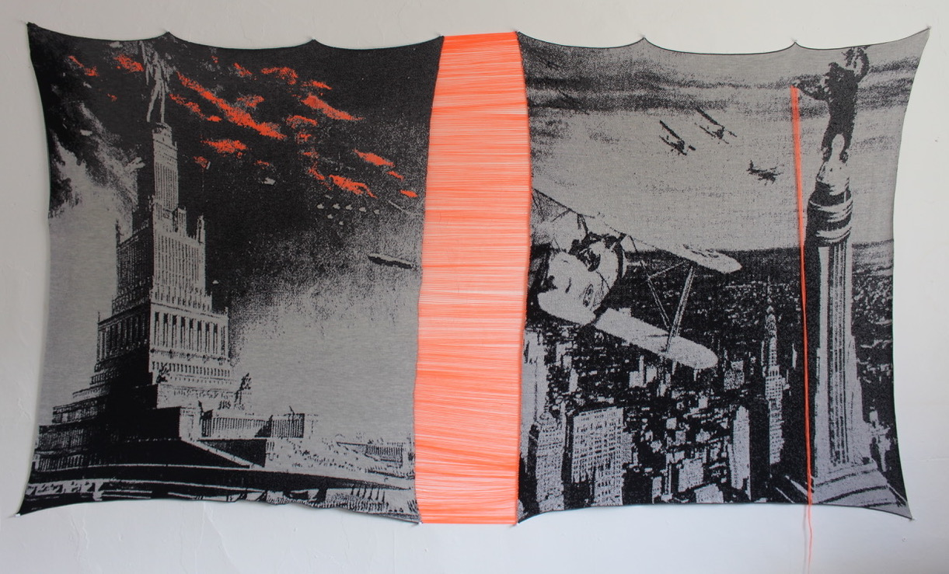

The Palace of the Soviets and King Kong
2020
Digital knitting, hand stitching and embroidery, wool and synthetic thread
122 cm x 255 cm

In these recent works created during the lockdown, I am questioning the symbols of global power and authority by juxtaposing iconic images from movie stills
and archival documents associated with the Communist and the Capitalist empirical architecture, the Palace of the Soviets and the Empire State Building.
I employ methodologies of knitting, stitching and embroidery to physically interlink the historically opponent political narratives that appear uncannily similar.
https://vimeo.com/438851207
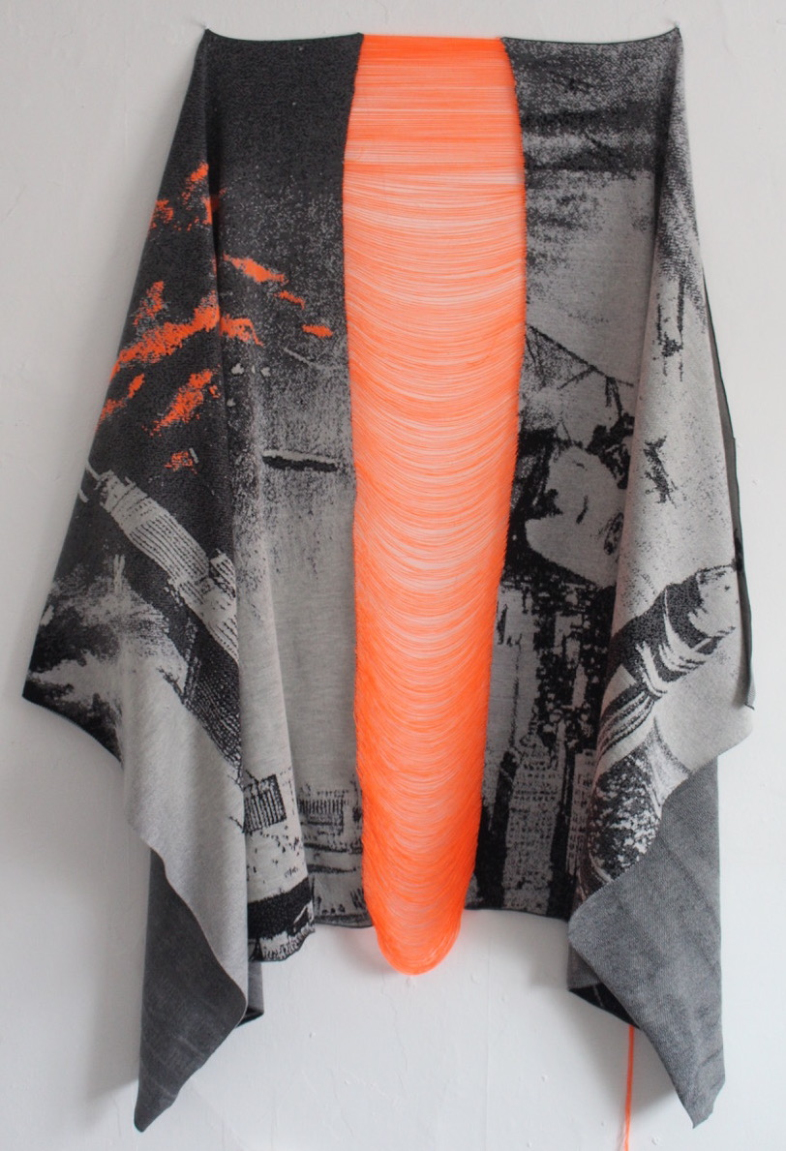

The Palace of the Soviets and King Kong (detail)
2020
Digital knitting, hand stitching and embroidery, wool and synthetic thread
122 cm x 255 cm
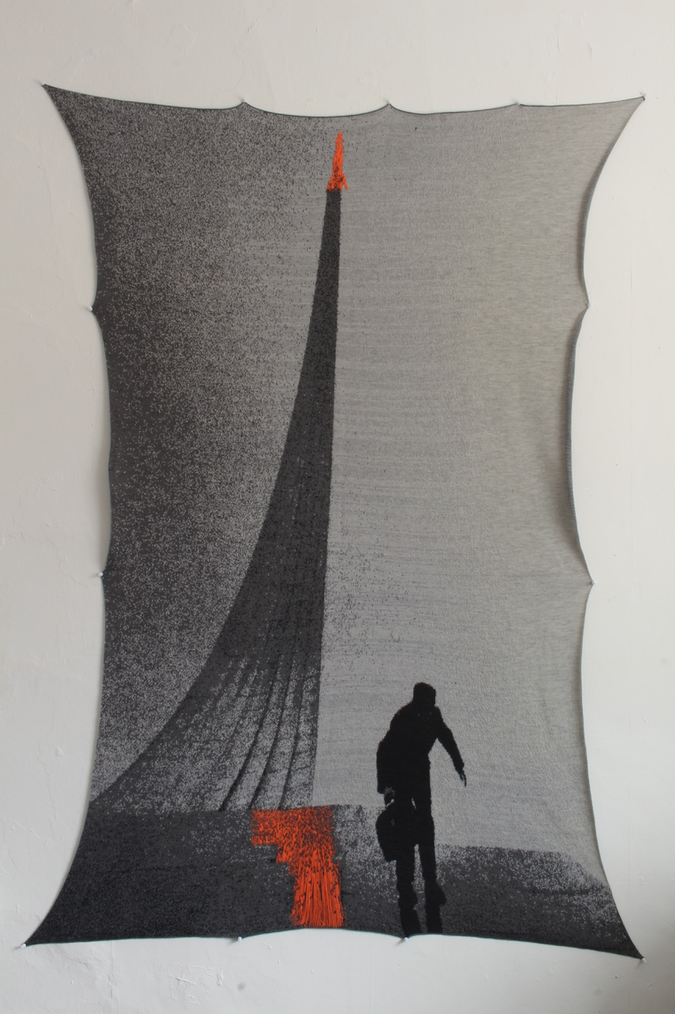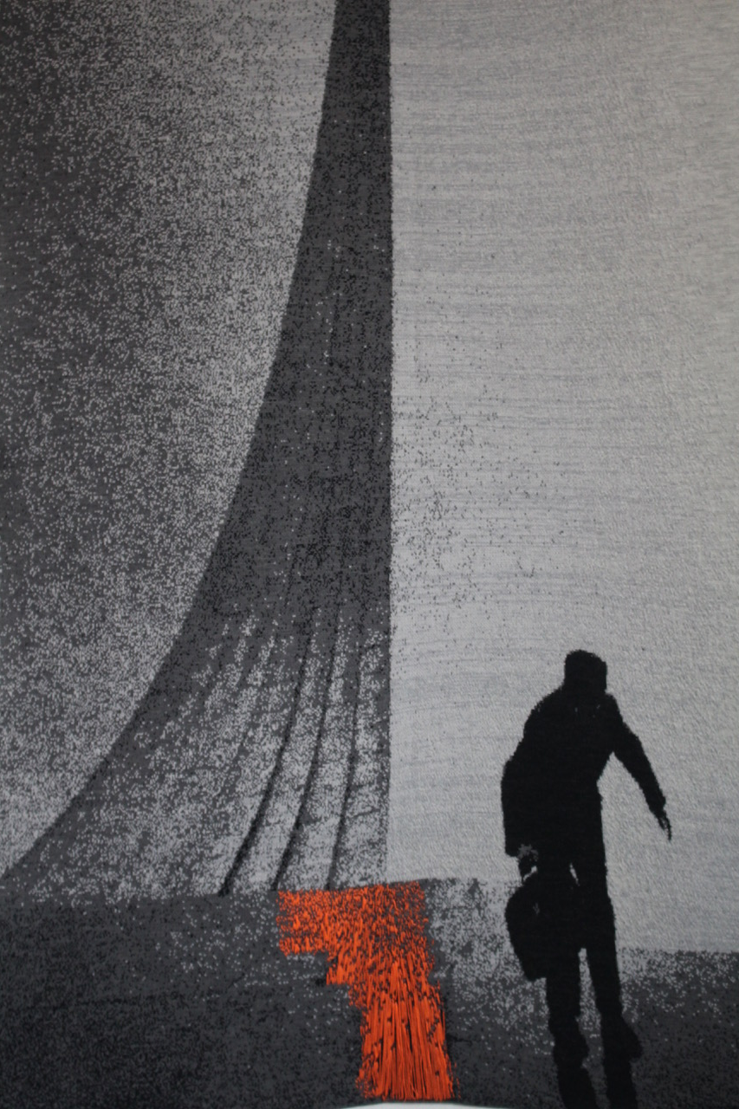

Monument to Cosmos
2020
Digital knitting, hand stitching and embroidery, wool and synthetic thread
100cm x 178cm

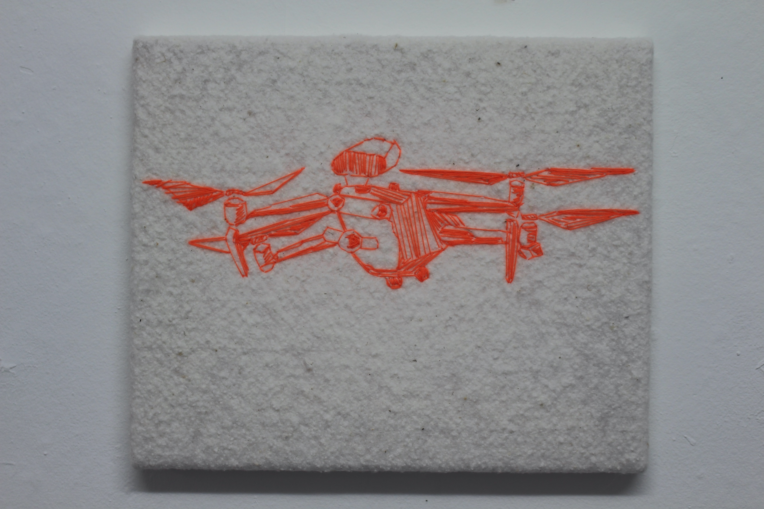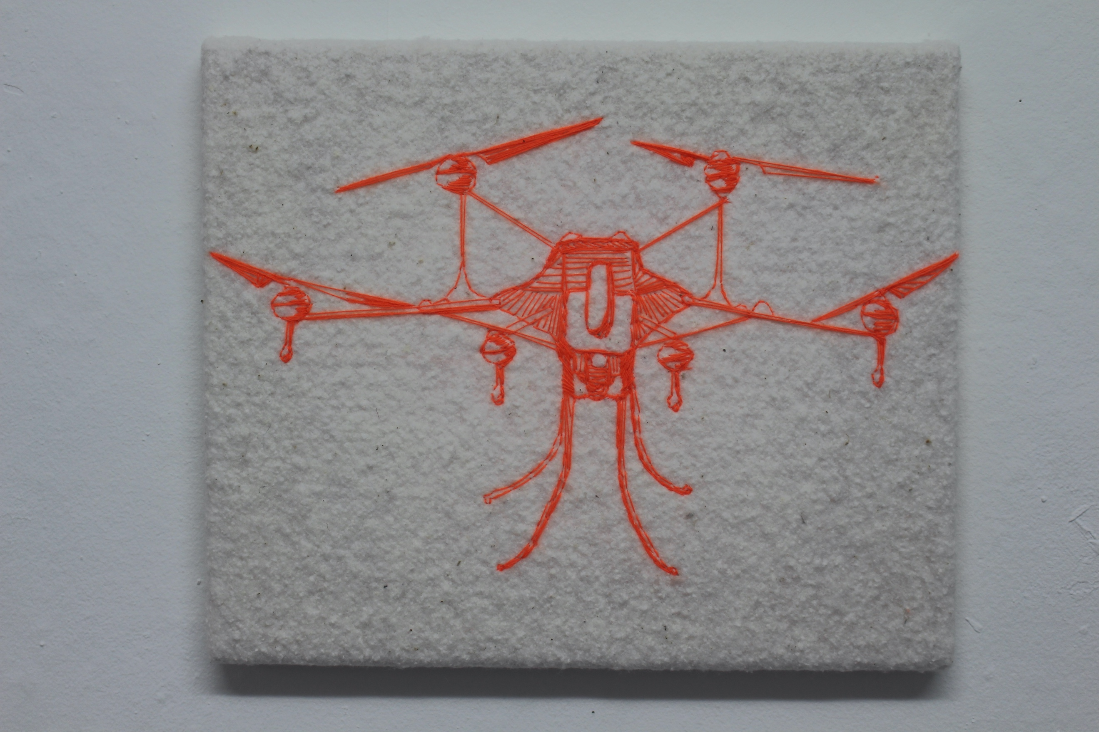

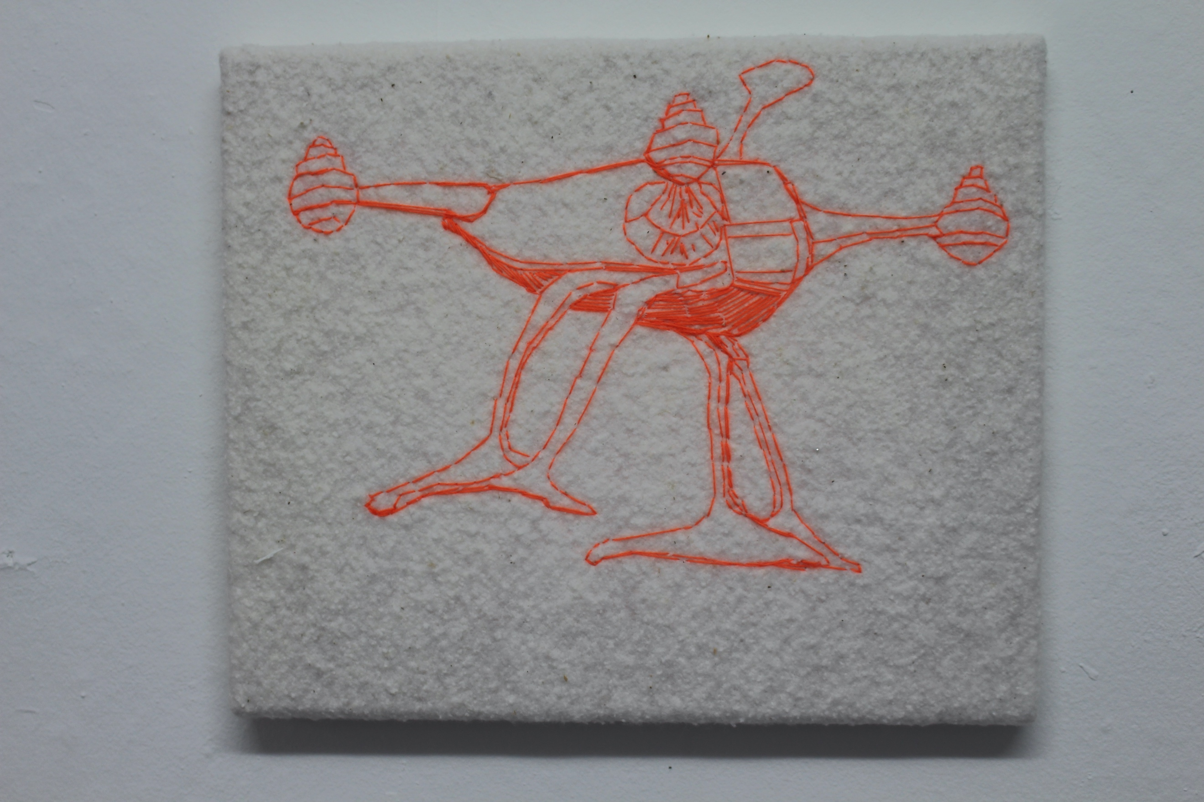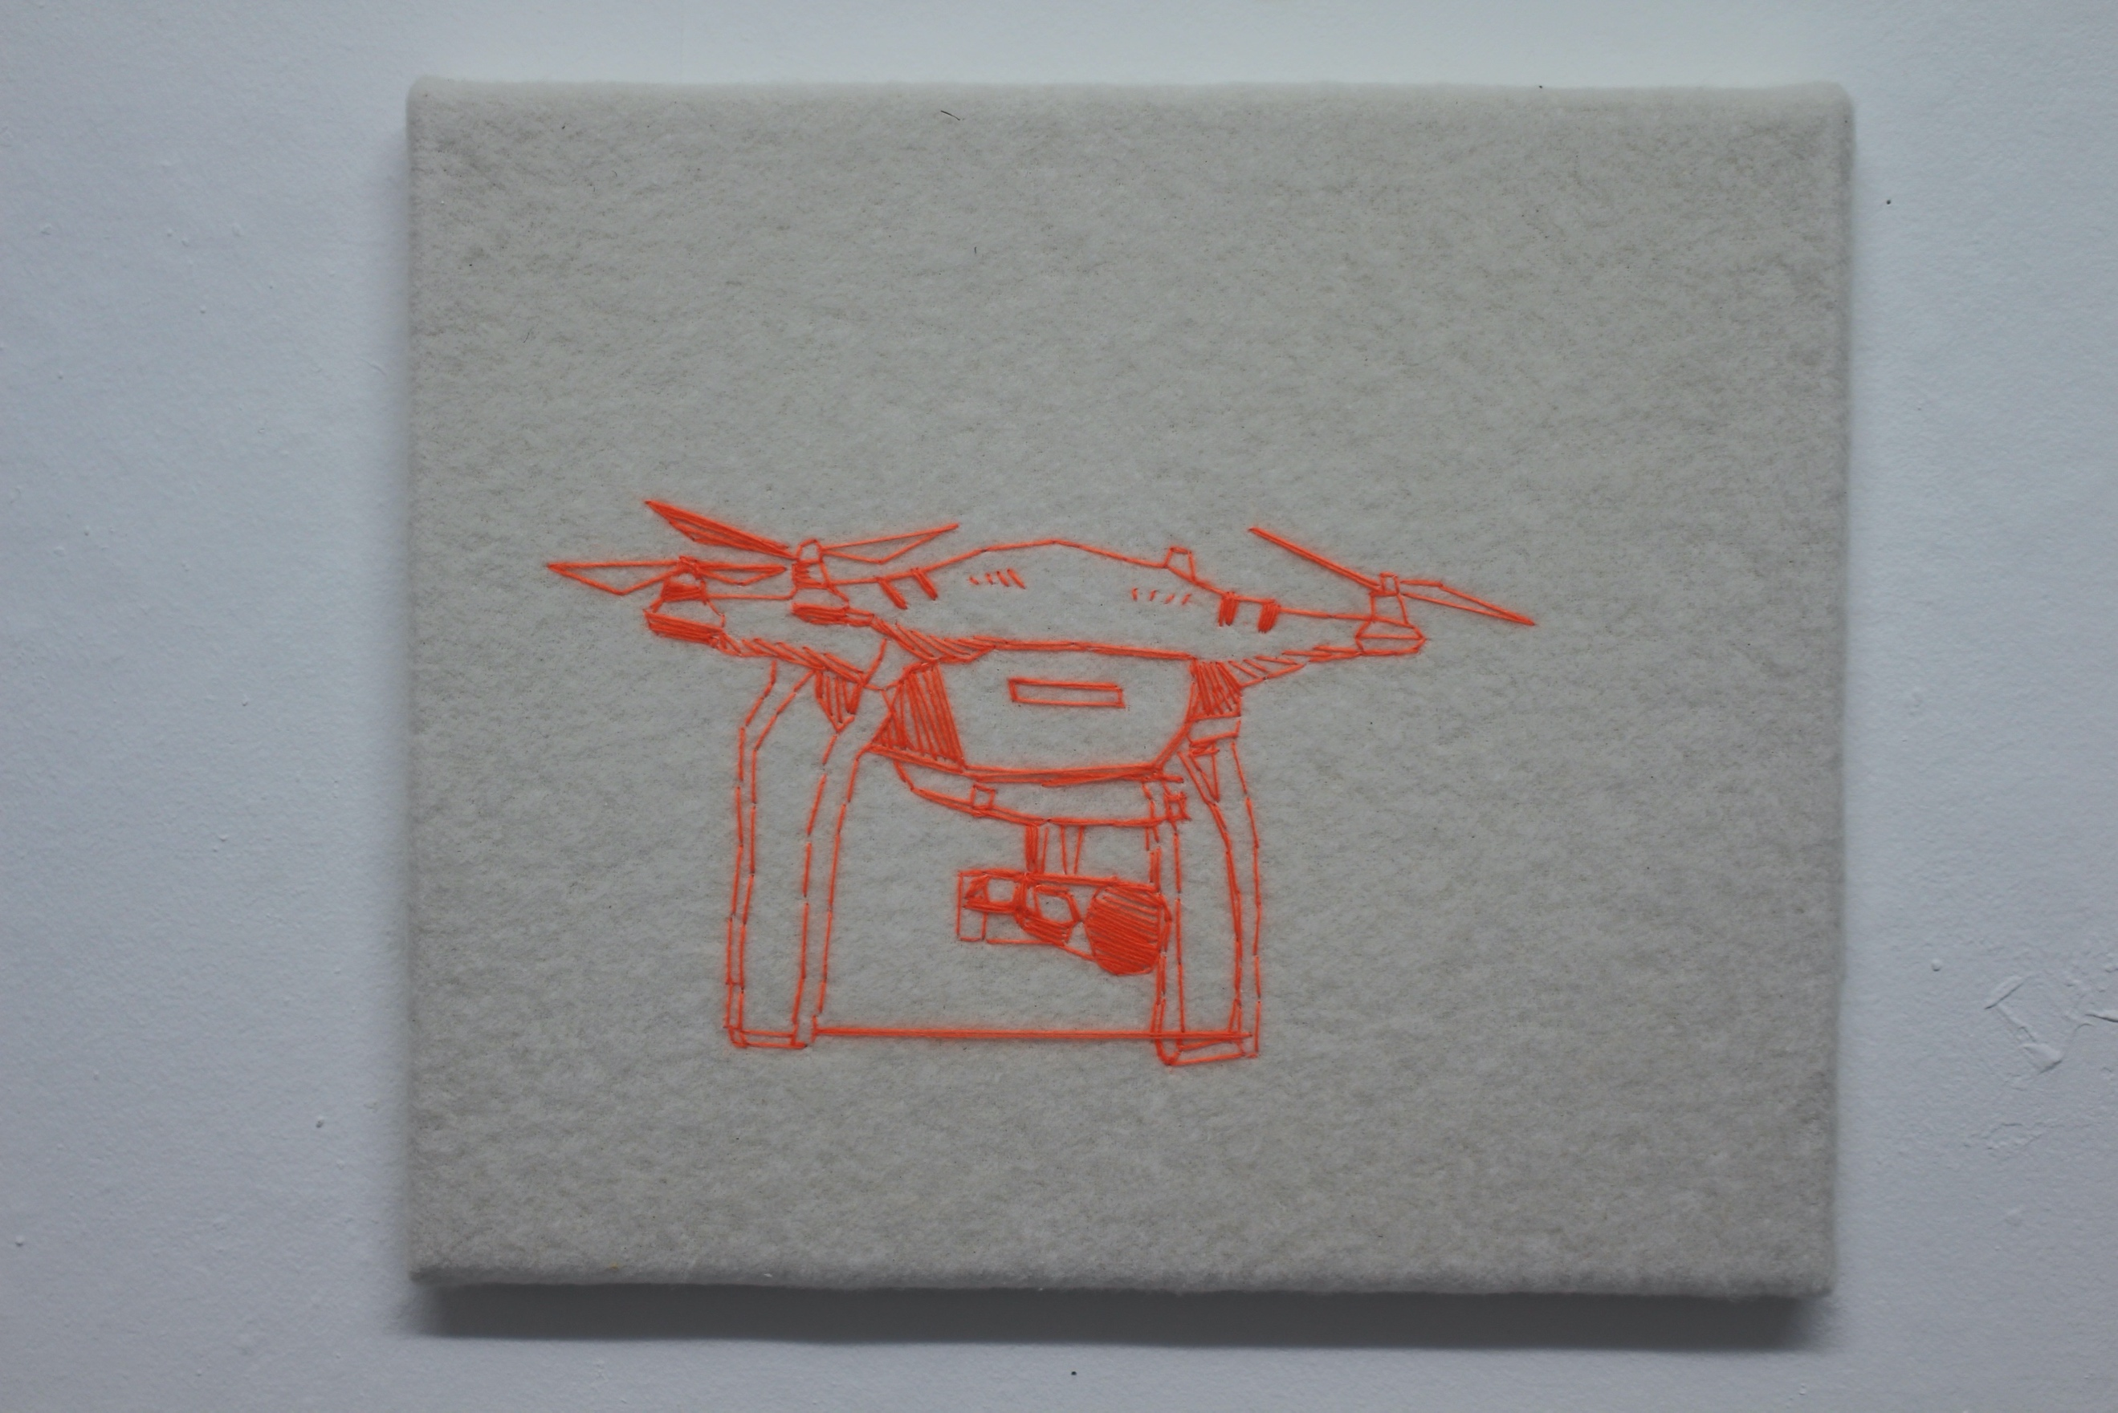

Soft Drones
2020
Hand stitching and embroidery.
25cm x 30cm each
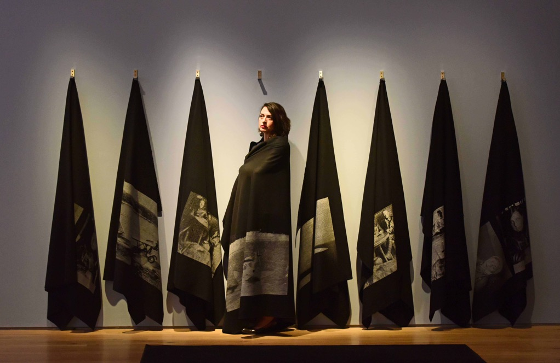

Blankets Project
2018-2019
Eight felt blankets, screen print, metal hinges
Overall dimensions 10 metres 1.9 metres by 20cm
The Sea is the Limit exhibition at York Art Gallery, installation view
Photo Anthony Chappel-Ross

This is the project about migration and borders, belonging and alienation, statelessness and trauma. As part of The Sea is the Limit project
I made a series of eight printed felt blankets that reflect on the experience of being a migrant. The blankets are conceived as an interactive
installation, where the participants are invited to wear the blankets in the exhibition space as an act of sharing and empathy.
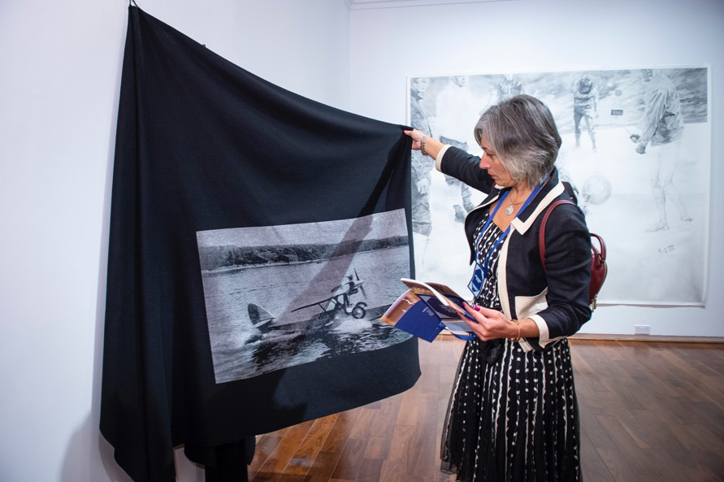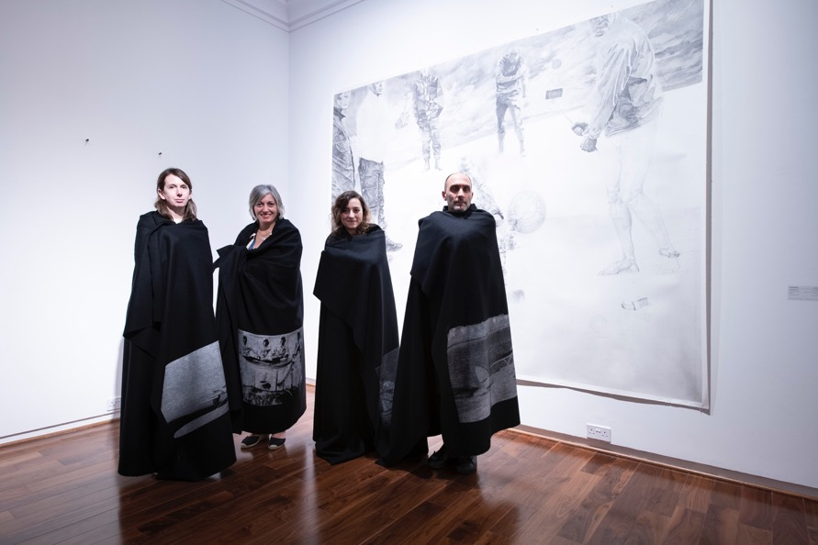

Blankets Project
2019
Eight felt blankets, screen print, metal hinges
Overall dimensions 10 metres 1.9 metres by 20cm
The Sea is the Limit exhibition at Virginia Commonwealth University Gallery Qatar, installation view
Photo Raviv Cohen

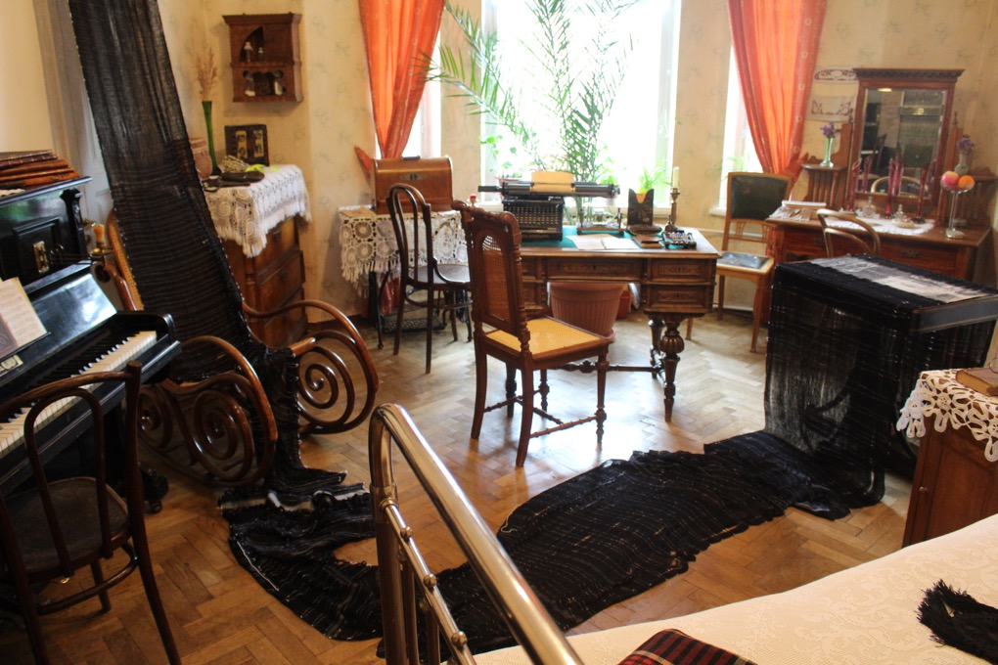

Mapping Fates
2017
Hand loomed jacquard tapestries, wool, silk, thread, photographs, objects, sound
Vladimir Lenin’s apartment in St.Petersburg, installation view
Facts and Fictions ProArte14 festival of contemporary art in traditional museums, St. Petersburg

Installation featuring texts, textiles, poetry and sound at the apartment where Vladimir Lenin lived in St. Petersburg. Using the archival material from
my Russian and Georgian families, I interweave the private and the public narrative, creating a complex web of stories and perceptions, facts and fictions,
realities and dreams. Commissioned by ProArte14 festival of contemporary art in traditional museums, St. Petersburg

https://vimeo.com/247702790
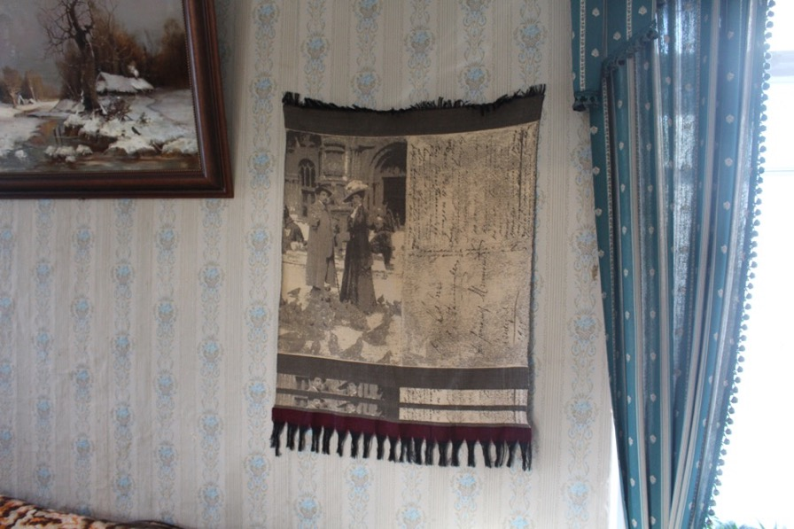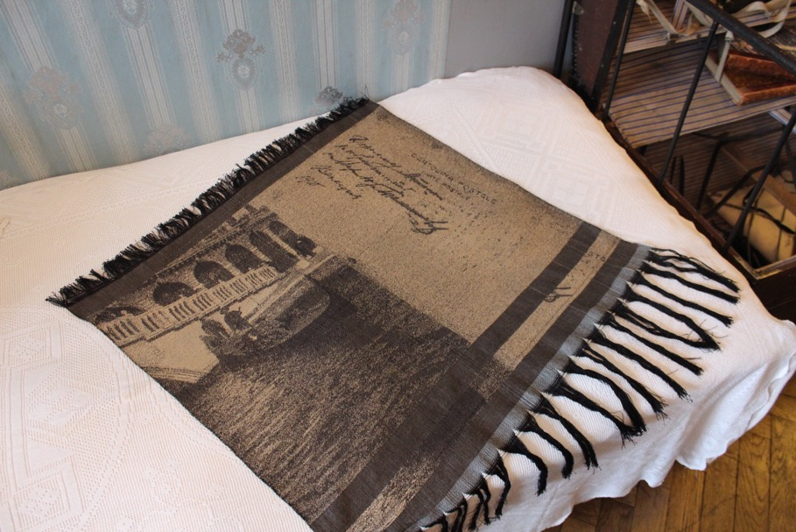

Mapping Fates
2017
Hand loomed jacquard tapestries, wool, silk, thread, photographs, objects, sound
Vladimir Lenin’s apartment in St.Petersburg, installation view
Facts and Fictions ProArte14 festival of contemporary art in traditional museums, St. Petersburg

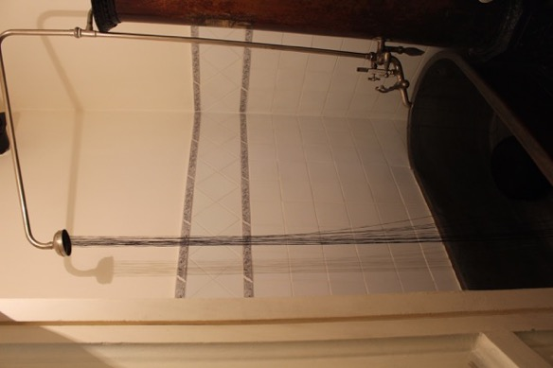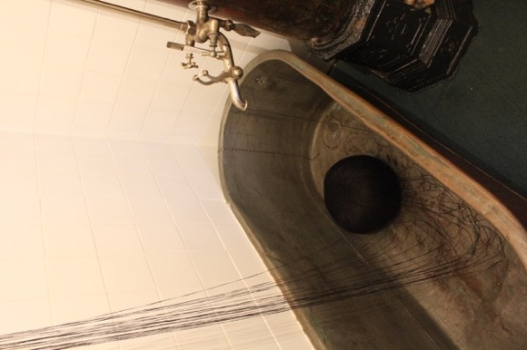

Mapping Fates
2017
Hand loomed jacquard tapestries, wool, silk, thread, photographs, objects, sound
Vladimir Lenin’s apartment in St.Petersburg, installation view
Facts and Fictions ProArte14 festival of contemporary art in traditional museums, St. Petersburg

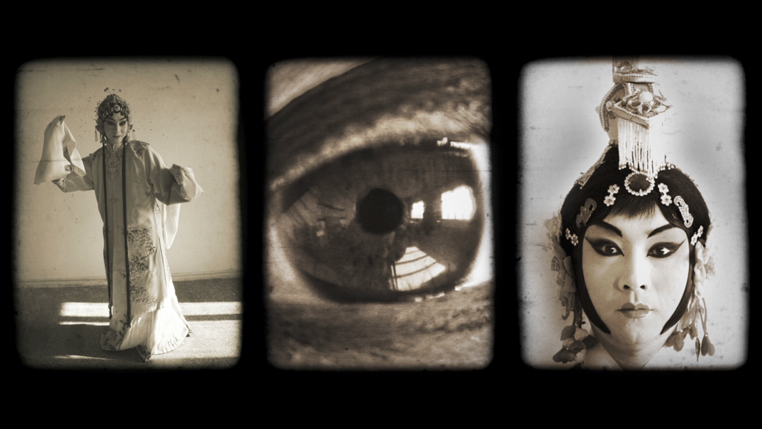
The Opera. Three Transformations.
2010-2016
3 min 41 sec
HD video projection with sound, looped
Exhibited at the 2014 Venice Biennale of Architecture. Part of Momentum Collection
The Opera is an insight into the fragile world of the Peking Opera, one of the most revered artforms of the Chinese national scene. The work focuses on the transformation
from male to female, and from female to male, of the Peking Opera artists. Balancing moments of pure visuality with behind the scenes footage, the video underscores the
striking avantgardist qualities of this most traditional of artforms. The Opera is accompanied by a specially commissioned score by composer Benoit Granier, and incorporates
elements of traditional Chinese and contemporary electronic music. Commissioned by Espacio Cultural El Tanque, Tenerife and Gallery of Photography, Ireland in collaboration
with Temple Beijing, Momentum Berlin and Patrick Heide Contemporary Art London.

https://vimeo.com/124918980
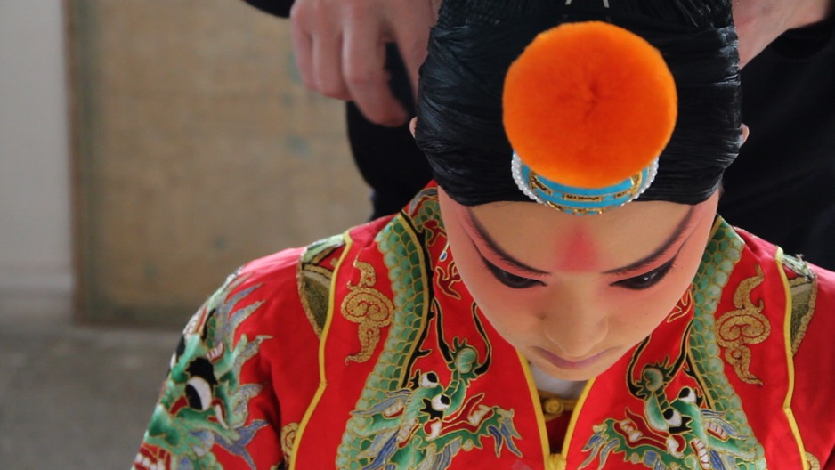

The Opera
2010-2016
21 min 23 sec
Video still
HD video projection with sound, looped
Exhibited at Espacio Cultural El Tanque, Tenerife and Temple, Beijing
https://vimeo.com/124910690

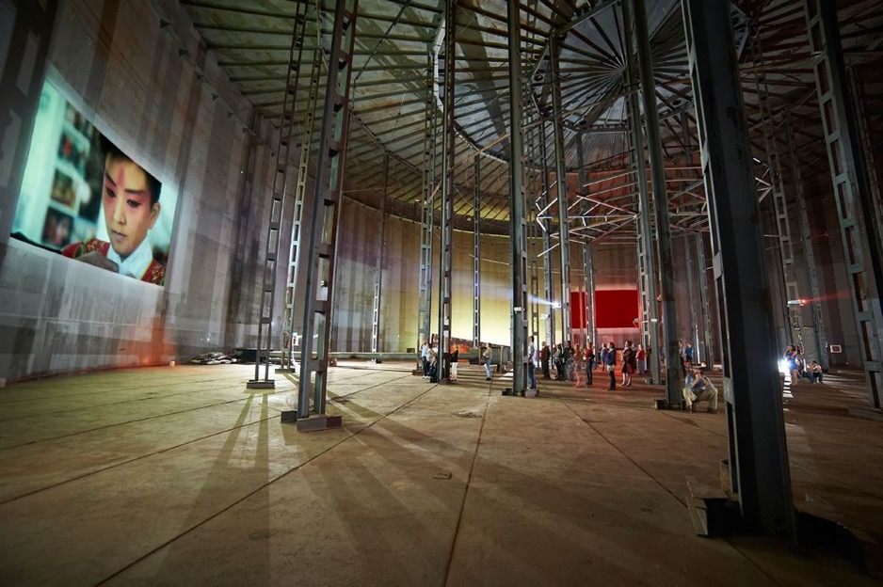
The Opera.
201130 min
6-screen HD video projection with sound, looped
Installation at Espacio Cultural El Tanque, Tenerife

